DVD Logo Any%
Misc · Easy
Description | My friends used to sit in front of the DVD bouncing logo and try to predict when the DVD would hit the corner perfectly. Now that I have my math PhD from Colorado School of Mines, I think I should be able to predict this quite easily.  An old DVD promises a bonus feature after eight perfect predictions. The menu is just that familiar bouncing logo. I remember losing entire afternoons to this thing, and I have a convention to get back to.
Files | Single Docker container, built from challenge/. From this folder:  docker build -t rowdy-dvd10:review challenge  docker run -d --name rowdy-dvd10-review -p 18110:18110 \  --read-only --cap-drop ALL --security-opt no-new-privileges \  rowdy-dvd10:review  Open http://localhost:18110. Players receive the URL and Export all rounds (/api/rounds). Keep the server image/source, organizer tools, screenshots, and this document private. Stop/update commands and session behavior: organizer/AUTHORING.md.
Hint(s) | 1. The moving point is the logo's corner, so its travel area is smaller than the full screen.  2. Mirror the screen at its edges. A bouncing path becomes a straight line through repeated rectangles.  3. Solve the horizontal and vertical boundary-hit congruences, then combine their periods. Some pairs have no common solution.
Walkthrough | Use the exported dimensions and starting coordinates to predict each logo's first corner tick. Find when the horizontal and vertical motions reach their edges together, or enter never if they cannot. Eight accepted predictions unlock the flag without waiting.  1. Read Original round data beside the preview. Predict the first positive integer corner tick, or never. Tick zero does not count.  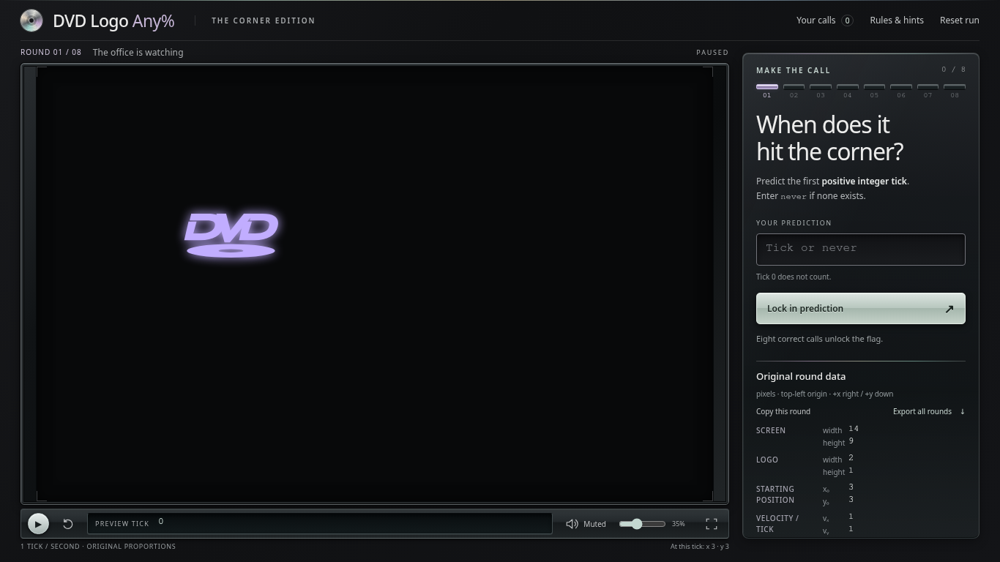  2. Download the data with curl; replace the URL if needed. Round 1's screen is 14 by 9 and logo is 2 by 1. Subtract to get the top-left corner's travel bounds: 12 by 8. Its start is (3,3) and velocity is (1,1).  BASE=http://localhost:18110  curl -sS "$BASE/api/rounds" -o dvd-rounds.json  3. Mirror the screens so a bouncing path becomes straight. For round 1, 3+t reaches a multiple of 12 at ticks 9, 21, 33… and a multiple of 8 at 5, 13, 21…. The first shared tick is 21. Enter 21, click Lock in prediction, then Next round.  4. For every other round, solve v*t = -s mod B on each axis: s is its starting coordinate, v its velocity, and B its effective bound. “Mod” means equal remainders after division. Set g = gcd(v,B), the greatest common divisor. If s is not divisible by g, submit never. Otherwise the period is p=B/g; the hit times are t=a mod p, where a=(-s/g)*inverse(v/g) mod p. A modular inverse undoes multiplication; Python writes it as pow(v//g, -1, p). If p=1, use a=0.  5. Combine the two schedules t=a mod m and t=b mod n. Set g=gcd(m,n). If (b-a) is not divisible by g, they never meet: round 3 has 9 mod 12 and 3 mod 8, so its answer is never. Otherwise write t=a+m*k and solve k=((b-a)/g)*inverse(m/g) mod (n/g). Use k=0 if n/g=1. Reduce t modulo L=m*(n/g). When the result is zero, use L to obtain the first positive tick. These steps are the generalized Chinese remainder theorem.  6. Apply that calculation with Python 3.8+ and the linked Python solver, saved as organizer/solve.py under your working folder. Its axis function reduces each schedule, predict combines them, and Client keeps the session cookie while submitting answers in order. It reads only the public API. Python integers keep the large answers exact.  python3 -B organizer/solve.py "$BASE"  The predictions for rounds 1–8 are:  01: 21 02: 22 03: never 04: never  05: 128 06: 537117701399620543 07: 4000000025  08: 7000000000000000003430000000000000000273  7. The script prints cleared: 8 and the flag. To finish in the browser too, enter the remaining predictions in order and click Next round after each accepted answer. Your calls keeps the accepted predictions. Browser and script sessions are separate. After the final prediction, the reward appears beside the actual accepted corner. Copy flag copies the server-issued reward.  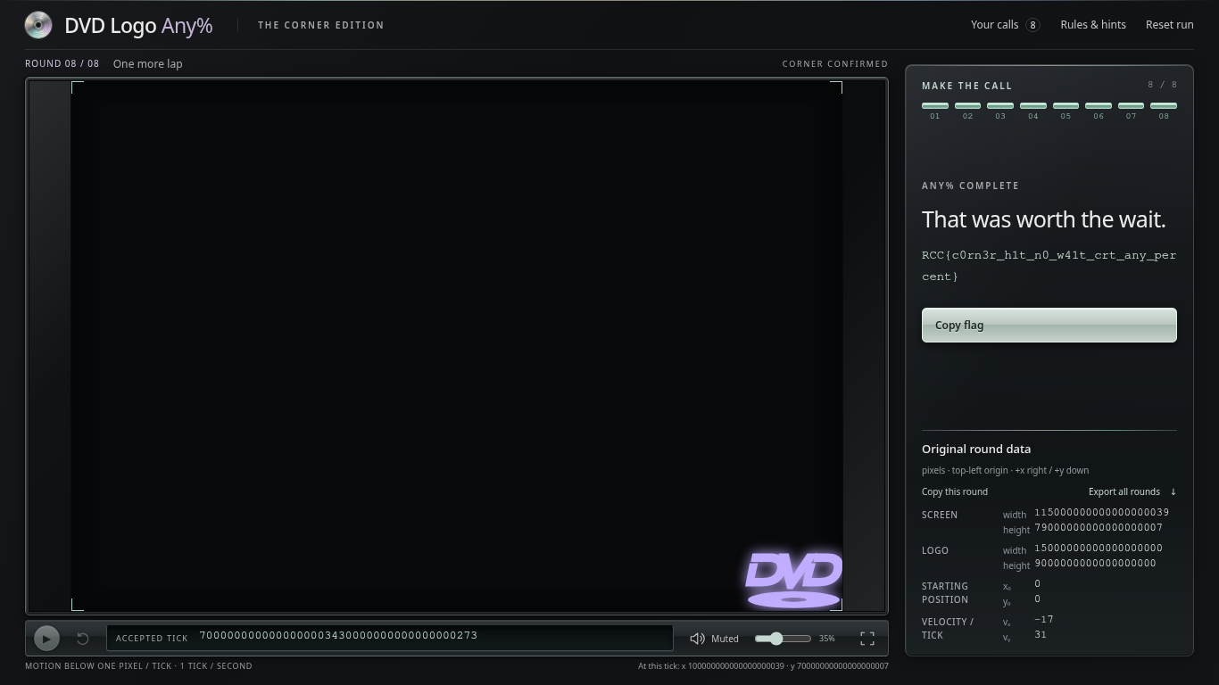
Flag | RCC{c0rn3r_h1t_n0_w41t_crt_any_percent}

